**Task 3 Report**

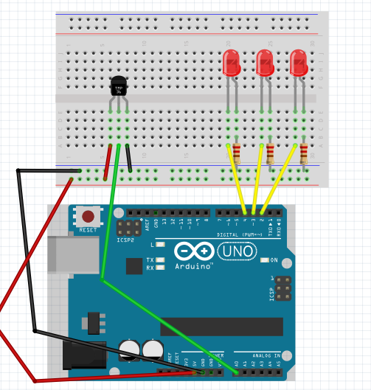

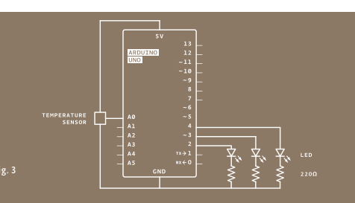

in task 3, I can through touch temperature sensor to change voltage and temperature then controlled led light on.

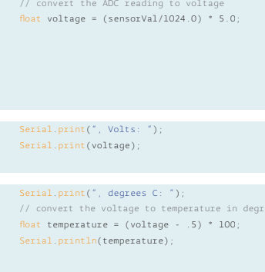

We can through voltage to calculate the temperature.

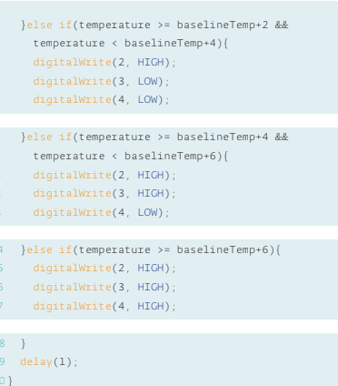

Use if to set condition of led light on.